**Task:** Select a target protein (e.g., **PD-1** or another target of choice). The goal is to detect and characterize the protein's binding pockets using Fpocket (alternatively, mdpocket), followed by a Molecular Dynamics (MD) simulation to analyze the stability and dynamic behavior of the pockets.

1. **Download the structure of the target protein (PD-1)**: choose high-res pdb **7WSL**, resolution 1.53A.

* rebuilt missing residues with id: **88 – 92**

1. **Pocket Detection and Characterization in PD-1 protein** (using [**Fpocket-3 Web Service**](https://durrantlab.pitt.edu/fpocketweb/)):

fpocket --file 7WSL_min.pdb --iterations_volume_mc 300 --min_spheres_per_pocket 15

--number_apol_asph_pocket 3 --ratio_apol_spheres_pocket 0

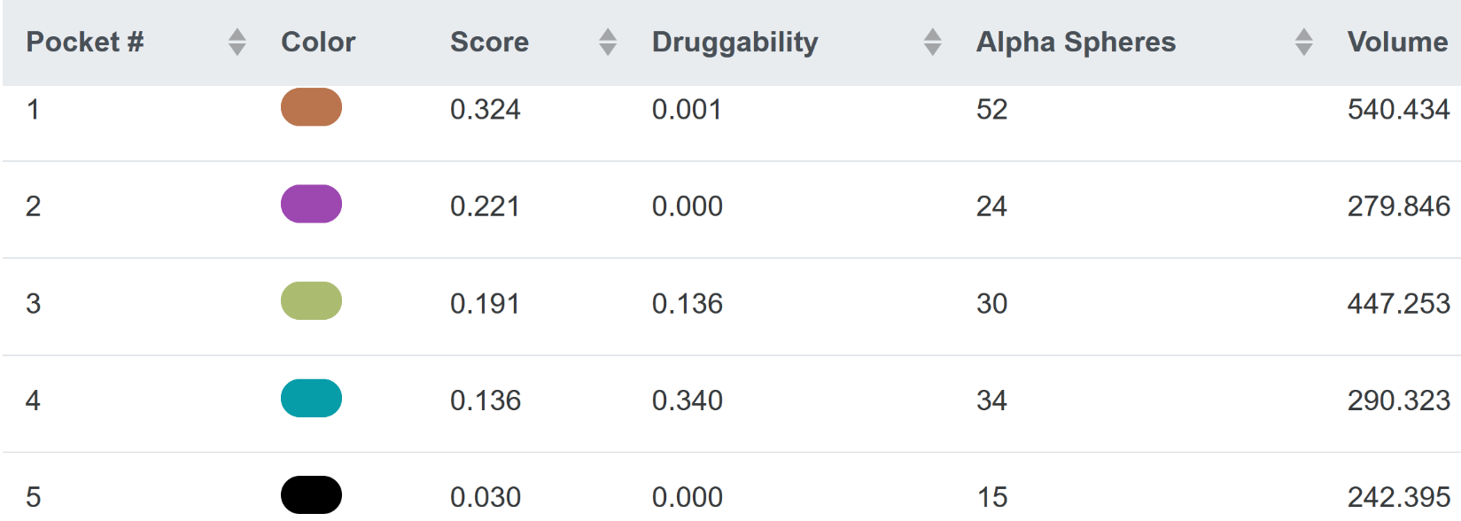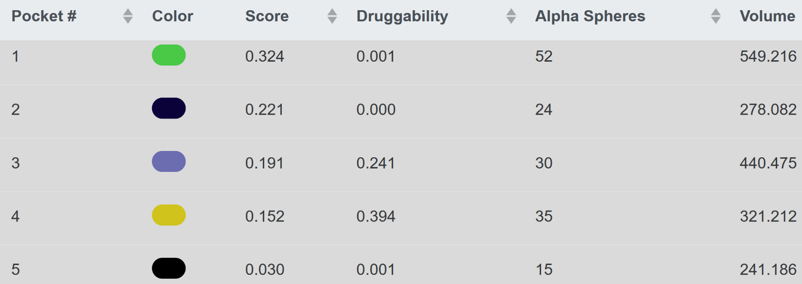 **Detected 5 pockets:**

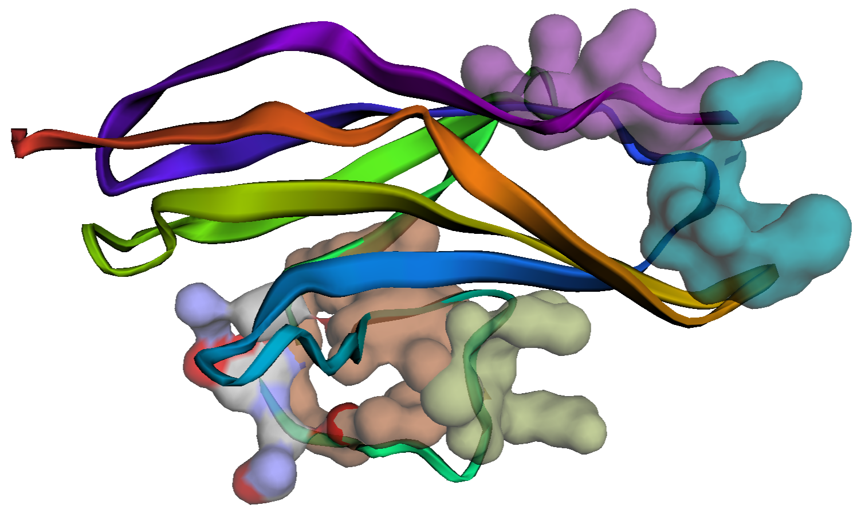**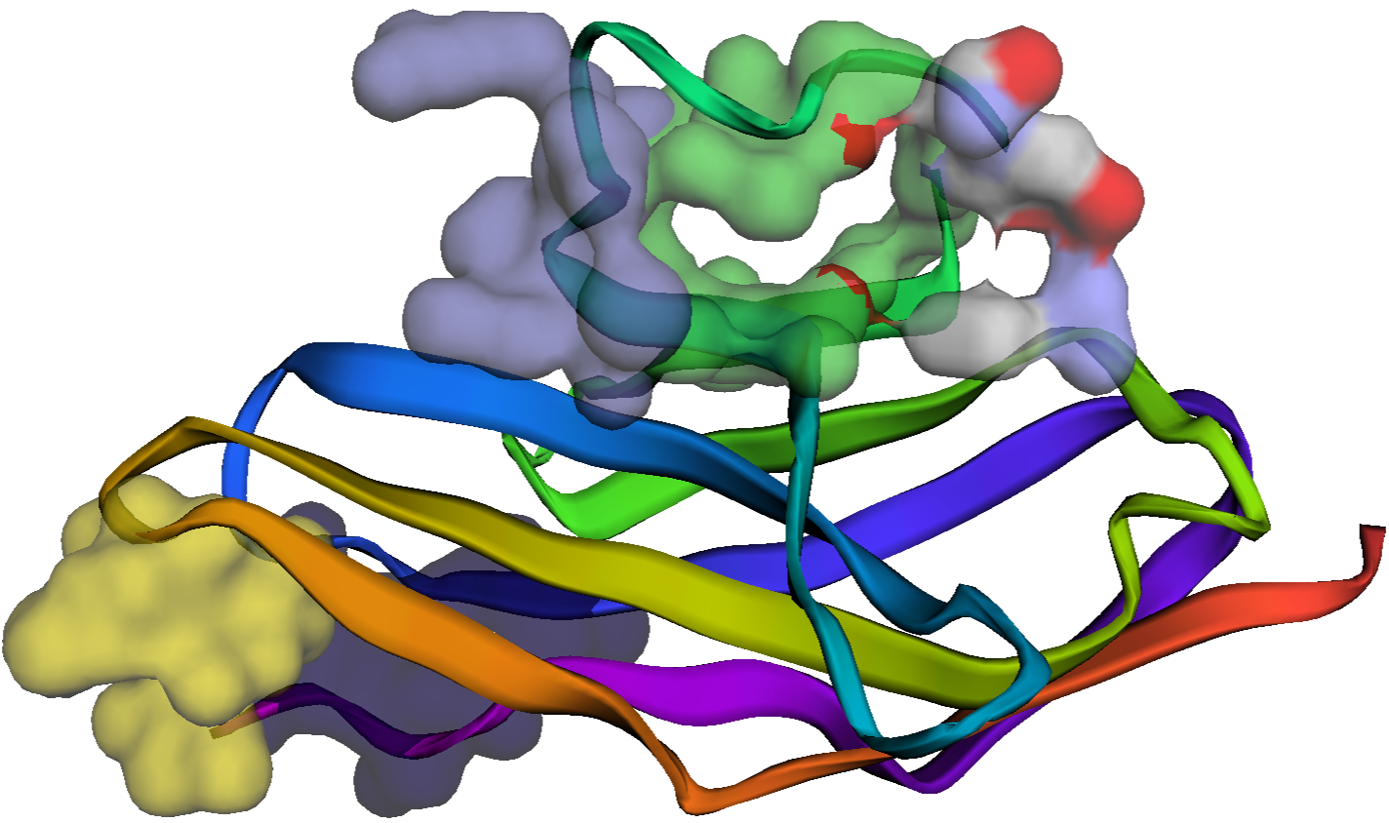Location of pockets in PD-1 protein**

**Table 1. Pocket details (descriptors)**

|  |  |  |  |  |  |
| --- | --- | --- | --- | --- | --- |
| **pocked id** | **1** | **2** | **3** | **4** | **5** |
| **Score :** | 0.324 | 0.221 | 0.191 | 0.136 | 0.03 |
| **Volume :** | 540.434 | 279.846 | 447.253 | 290.323 | 242.395 |
| **Proportion of polar atoms (%):** | 54.286 | 50 | 34.783 | 38.095 | 56.25 |
| **Hydrophobicity score:** | 11.5 | 3.8 | -10 | -2.857 | 9.571 |
| **Druggability Score :** | 0.001 | 0 | 0.136 | 0.34 | 0 |
| Total SASA : | 138.591 | 83.152 | 112.521 | 99.756 | 86.603 |
| Polar SASA : | 80.625 | 32.431 | 29.195 | 15.222 | 52.789 |
| Apolar SASA : | 57.966 | 50.72 | 83.326 | 84.534 | 33.814 |
| Apolar alpha sphere proportion : | 0.135 | 0.042 | 0.567 | 0.559 | 0.467 |
| Mean local hydrophobic density : | 4.286 | 0 | 13.529 | 18 | 6 |
| Mean alpha sphere radius : | 4.036 | 3.761 | 4.026 | 3.968 | 3.965 |
| Mean alp. sph. solvent access : | 0.446 | 0.54 | 0.545 | 0.494 | 0.548 |
| Volume score: | 3.786 | 4 | 4 | 4.143 | 4.286 |
| Polarity score: | 7 | 7 | 5 | 5 | 4 |
| Charge score : | 0 | 1 | 0 | 1 | 0 |
| Number of Alpha Spheres : | 52 | 24 | 30 | 34 | 15 |
| Alpha sphere density : | 4.412 | 4.027 | 4.341 | 2.876 | 3.077 |
| Cent. of mass - Alpha Sphere max dist: | 10.768 | 8.594 | 9.445 | 6.541 | 5.504 |

**Characterization and ranking of pockets**

Fpocket “**Score**” is recommended (in the original paper doi: [10.1186/1471-2105-10-168](https://doi.org/10.1186/1471-2105-10-168)) for ranking pockets. The scoring function was derived using Partial Least Squares fitting to some of the currently implemented pocket descriptors. In addition, recommended criteria include **Volume** > 200 A3, **Proportion of polar atoms** 20-60% and **Hydrophobicity Score** (higher is better).

According to above criteria most promising pockets are **pocket-1** and **pocket-2** which have highest fpocket **Score** and other metrics within the reasonable range. I chose the **pocket-1** for further analysis but also will compare its metrics with those of **pocket2**.

**Note,** those criteria do not reflect drugability. Fpocket **Score** simply reflects the putative capacity of the pocket to bind a small molecule, that might be drug-like, but might also be a sugar, cofactor or coactivator. Thus further filtering on pocket **Drugability** could be used to re-rank the top pockets (**not used in this Task**).

**MD Simulation Details**

* 1. Simulation box was prepared from the PD-1 structure with pdb code 7WLS (resolution 1.53A). The missing residues 88-92 were rebuild and appropriate protonation states assigned by the “protein_prep” routine of Schrodinger suite. The protein was solvated and neutralized in the box of TIP4PEW water with Na/Cl counterions at physiological 0.15M concentration resulting in simulation box of 30K atoms. The **Amber19SB** force-field topology was generated by AmberTools23 and then converted to Gromacs format using “parmed” utility.

The system was minimized and equilibrated in NVT and then NPT ensemble with Berendsen barostat and with protein heavy atoms restrained. The production MD simulation was carried out without restraints at physiological conditions T=298K, P=1atm for 300ns in NPT ensemble with Parinello-Rahman barostat using stochastic dynamics (sd) integrator and 2fs timestep applying constrains to all h-bonds. The trajectory was saved every 1ns resulting in 300 frames.

**Trajectory Analysis**

To analyze dynamics of all 5 pockets I have written a script “gen_pocket_idx.tcl” which generates gromacs index file with pocket’s atomic indices in the simulation box. The script uses fpocket **pocket_atm.pdb** files as an input.

**Results**

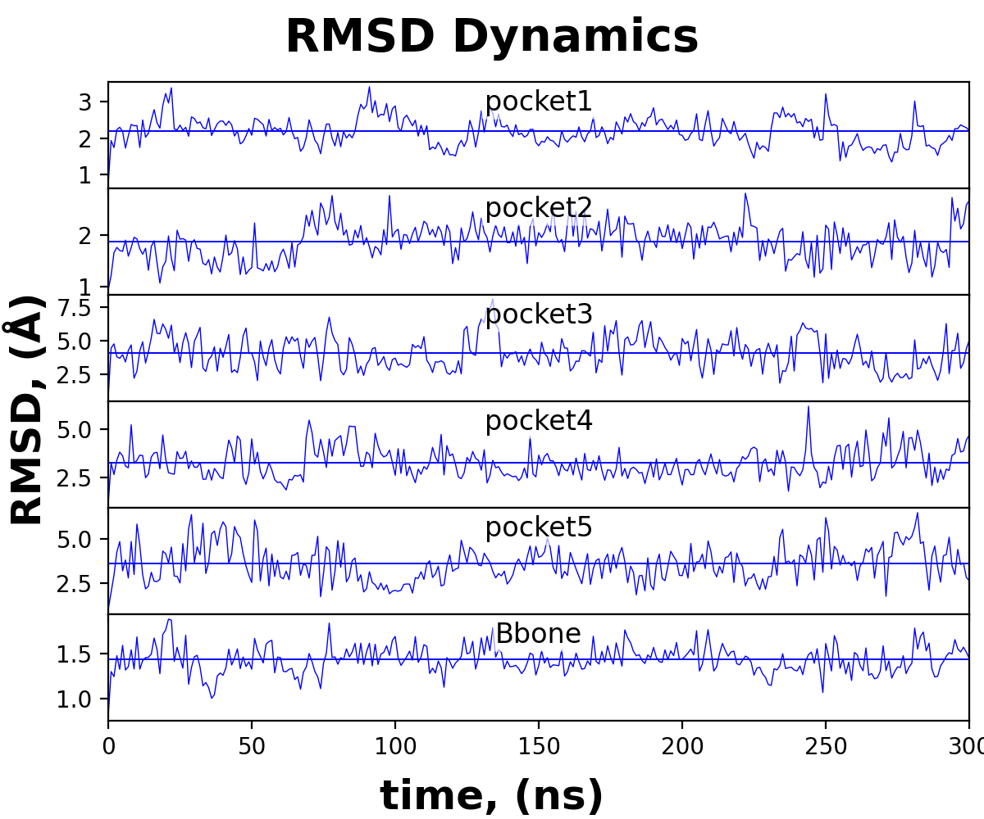**Fig 1** RMSD Dynamics of Pockets was computed in respect to the initial Xrays structure by **gmx rms** utility.

**Fig 2** RMSD (**a**) and RMSF (**b**) per Pocket residue computed by **gmx rmsf** utility.

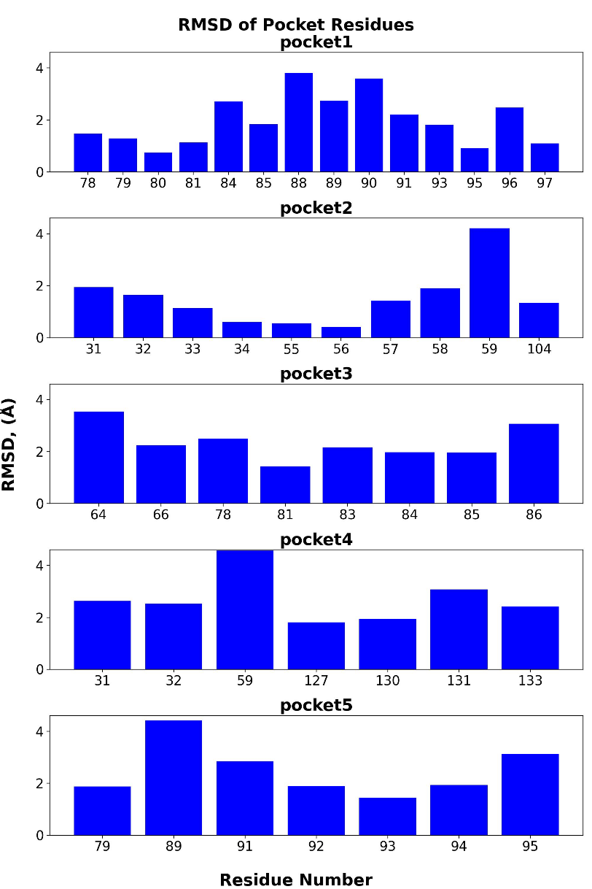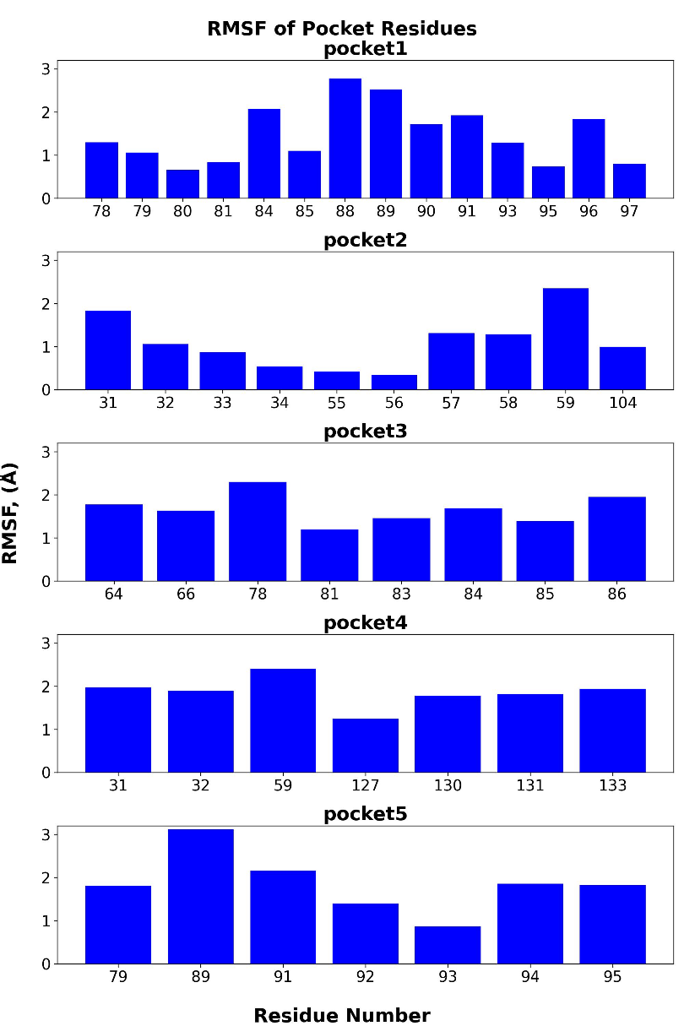

**Fig 3** SASA **(a)** and Gyration radius **(b)** of pockets computed by **gmx sasa** and **gyrate** utilities.

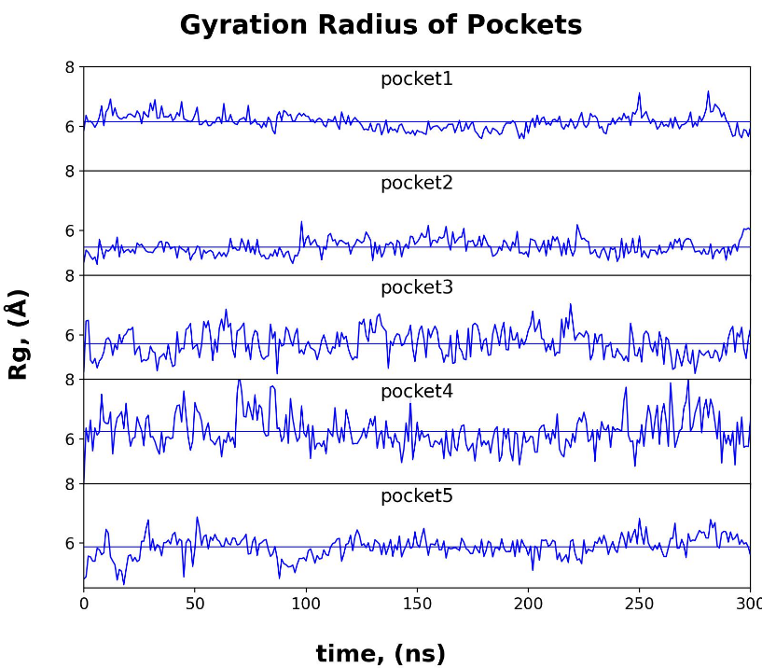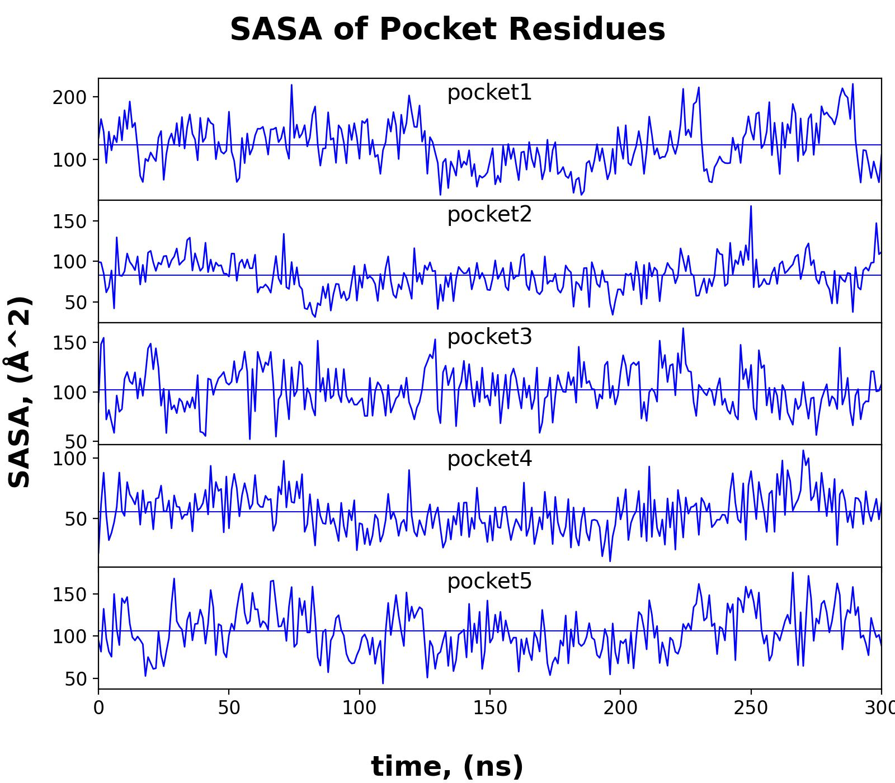

**Table 2. Pocket metrics (and fluctuations** σ**) averaged over the entire MD trajectory.**

|  |  |  |  |  |  |  |  |
| --- | --- | --- | --- | --- | --- | --- | --- |
| pocket id | **<rmsd>** | σ(rmsd) | **rmsf** | **<sasa>** | σ (sasa) | **Rgyration** | σ (Rg) |
| pocket1 | 2.18 | 0.37 | 1.49 | 123.12 | 36.14 | 6.15 | 0.26 |
| pocket2 | 1.89 | 0.34 | 1.29 | 82.68 | 20.25 | 5.45 | 0.26 |
| pocket3 | 4.12 | 1.19 | 1.69 | 102.40 | 21.36 | 5.71 | 0.45 |
| pocket4 | 3.26 | 0.75 | 1.88 | 55.65 | 16.81 | 6.25 | 0.58 |
| pocket5 | 3.62 | 0.99 | 1.66 | 106.16 | 26.80 | 5.87 | 0.36 |

**Discussion**

**Stability analysis of the binding pocket by RMSD:** A stable binding pocket will have a **low RMSD** value **(e.g., < 2 Å)** that reaches a plateau after a short time. A high RMSD indicates significant conformational changes. A significant jump or dip in the RMSD value may indicate a large-scale conformational change in the pocket. The RMSD curves in **Fig 1** can help determine if an MD simulation has run long enough to reach a stable, or "equilibrated," state of the pocket. If the pocket’s RMSD is significantly larger than 3Å then pocket is highly flexible or undergoes significant conformational changes, possibly opening and closing during the simulation.

**Ligand binding impact:** Comparing the RMSD of a pocket in its free (apo) versus ligand-bound (holo) state can show how a ligand affects the pocket's overall stability. A more stable, flatter RMSD curve in the holo complex suggests the ligand is stabilizing the pocket. In this task we don’t have ligands. The pockets are assessed based on dynamics of apo state.

**Conclusion: pocket1** and **pocket2** are essentially stable as average RMSDs is around 2 Å and RMSD fluctuations (σ) are low too (see Table 2). Reaching a plateau for **pocket2**, however, took a long time (>50ns) which may indicate a large-scale conformational change. Thus, the large-scale stability of **pocket1** is more probable.

**RMSF**

The RMSF measures the average fluctuation of individual pocket residues over the course of an MD simulation, see **Fig 2(b)**.  In a pocket analysis, low RMSF values for key binding residues suggest they are important for forming stable interactions with a ligand. High RMSF values indicate flexible loop regions that may be involved in induced-fit binding or allosteric regulation. Thus, RMSF analysis helps to identify important pocket regions**.**

* **Low RMSF (e.g., < 1 Å) for pocket residues** indicates that residues are constrained and participate in stable interactions with the ligand, reinforcing binding.
* **High RMSF (e.g., > 2 Å) for pocket residues** (e.g., in loop regions) is an indication that these residues are flexible and may not contribute strongly to stable interactions, but could be important for the induced fit conformational changes.

**Conclusion: pocket1** and **pocket2** have the lowest average RMSFs (see Table 2) among other pockets which indicates that their residues can participate in stable interactions with the ligand, reinforcing binding.

**SASA**

The SASA quantifies the surface area of a molecule that is accessible to a solvent. Monitoring the SASA of the pocket residues over time can reveal if the pocket is opening, closing, or collapsing during the simulation, see **Fig 3a**. Significant fluctuations in the overall SASA of the pocket can indicate structural instability or large conformational changes. A stable pocket will likely have a relatively constant SASA.

**Conclusion:** the **pocket1** SASA relative fluctuation is 30% of its average value, see **Table 2**. But the first 120 ns of simulations SASA was more stable while larger SASA changes started happening after 120ns (**see Fig 3a**).

**Gyration Radius**

* 1. The changes in pocket size and shape over time can be monitored by the pocket gyration radius, see **Fig 3b**.

**Conclusion: pocket1** and **pocket2** have significantly lower fluctuations (σ) of the gyration radius (see Table 2) among other pockets which indicates the stability of the pocket size and shape.

* 1. Thus overall (analyzing RMSD, RMSF, SASA and Gyration) the **pocket1** is the most promising pocket in terms of its stability which indicates that its residues can participate in stable interactions with the ligand, reinforcing binding.